# Data definition

Voor de users wordt het ingebouwde systeem van Django (django.contrib.auth) gebruikt. Django heeft de volgende models: User, Group, Permission, ContentType.

## Engineers

|  |  |  |
| --- | --- | --- |
| **Name** | **Column** | **Type** |
| Employee number | id | Integer, Primary key |
| First name | first_name | Varchar (100) |
| Last name | last_name | Varchar (100) |
| Droppoint | droppoint | Char (??) |
| Phone | phone | Char (11) |
| Email | email | Varchar (255) |
| VCA number | vca_number | Char (19) |
| VCA date | vca_date | Date |
| Car type | car_type | Varchar (100) |
| Car color | car_color | Varchar (100) |
| License plate | license_plate | Varchar (10) |
| Street | street | Varchar (100) |
| Zip code | zip_code | Varchar (10) |
| City | city | Varchar (100) |
| Country | country_id | TinyInt |

## Skills

|  |  |  |
| --- | --- | --- |
| **Name** | **Column** | **Data type (length)** |
|  | id | Integer  Primary key |
| Engineer | engineer_id | Integer  Index (engineer_id, product_id) |
| Product | product_id | Integer  Index |
| Skill level | level | TinyInt |

## Products

|  |  |  |
| --- | --- | --- |
| **Name** | **Column** | **Data type (length)** |
|  | id | Integer  Primary Key |
| Category | category_id | Integer |
| Model | model | Varchar (100) |
| Type | type | Varchar (100) |
| Crosslab | is_crosslab | Boolean |

## Categories

|  |  |  |
| --- | --- | --- |
| **Name** | **Column** | **Data type (length)** |
|  | id | Integer  Primary Key |
| Short name | short_name | Char (2) |
| Full name | name | Varchar (100) |
| Parent category | parent_id | Nullable Integer  Index |

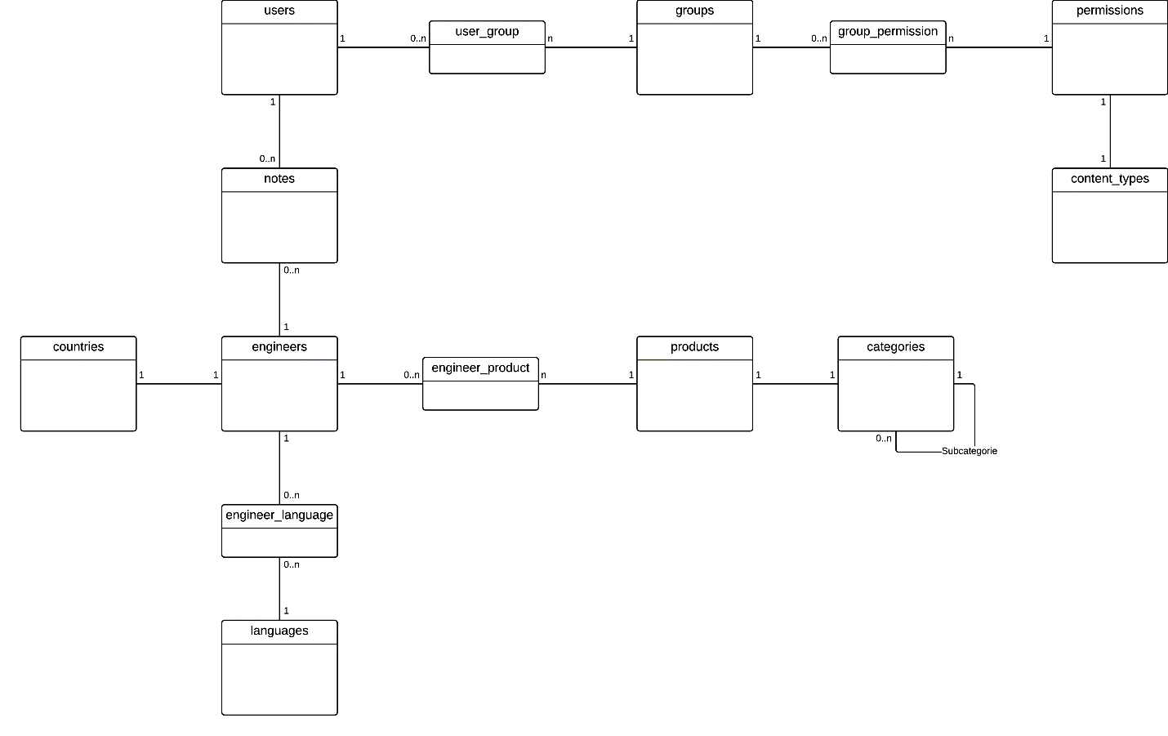

## Notes

|  |  |  |
| --- | --- | --- |
| **Name** | **Column** | **Data type (length)** |
|  | id | Integer |
| Content | content | Varchar (255) |
| Shows from this date | visible_from | Nullable date |
| Shows until this date | visible_until | Nullable date |
| Created at | created_at | DateTime |
| User | user_id | Integer |

## Countries

|  |  |  |
| --- | --- | --- |
| **Name** | **Column** | **Data type (length)** |
|  | id | Integer |
| ISO Code | Code | Char (2) / Char (3) |
| Full name | name | Varchar (100) |

## Languages

|  |  |  |
| --- | --- | --- |
| **Name** | **Column** | **Data type (length)** |
|  | id | Integer |
| ISO Code | Code | Char (2) / Char (3) |
| Full name | name | Varchar (100) |

## Speaks

Tabel-naam wordt waarschijnlijk *engineer_language*

|  |  |  |
| --- | --- | --- |
| **Name** | **Column** | **Data type (length)** |
|  | id | Integer |
| Language | language_id | Integer |
| Engineer | engineer_id | Integer |